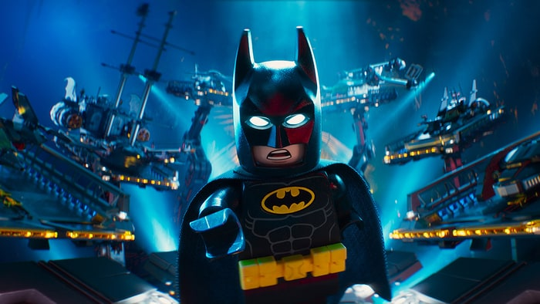
'The Lego Batman Movie' Review: Welcome to the Funniest Dark Knight Movie Ever
Will Arnett and a who's who of superhero toys turn this 'Lego Movie' spin-off into a superfun time
By Peter Travers February 8, 2017

Is it possible that every movie would be better with Legos? Suicide Squad, for sure. And, of course, Batman v Superman: Dawn of Justice. How do I know? Because The Lego Batman Movie, animated with love and lunacy, is the funniest Caped Crusader movie ever. Will Arnett may have found the role of his career voicing the growly Dark Knight as a delusional, ego-centric freak willing and eager to mine laughs out of his own psychosis, Hollywood's plastic soul and every Bruce-Wayne/Batman from Adam West to Ben Affleck. The kids are gonna love it, even if the inside jokes, Freudian subtext and subversive jabs at corporate America sail right over their towheads. As for the, grown-ups, they'll eat up the antics of this newly lighthearted DC vigilante. "I have aged phenomenally," he beams. And for the under-10 crowd – pampered with poopy-level sight gags and "wanna-get-nuts" action – everything is PG awesome.
If any shadow hangs over this enterprise, it's 2014's The Lego Movie, which got there first and struck creative gold in the madly creative hands of co-directors/co-writers Phil Lord and Christopher Miller. That team is gone now, off to make a Han Solo-centered Star Wars movie, and their cheeky irreverence is much missed in Gotham City. But Chris McKay steps in ready to party. And since McKay was animation director and editor on The Lego Movie, he already knows the drill.
It begins in the dark: "All important movies start with a black screen," explains Arnett's Batman, satirizing the comic-book universe in one fell voiceover swoop. (Funny idea. It would have been funnier if Deadpool hadn't beaten it to the punch, but still.) The plot, cooked up by more writers than I care to type, kicks in as Batman the loner is confronted by the Joker (hilariously voiced by Zach Galifianakis), the surprisingly sensitive arch-villain who wants the dude in the mask to admit that they "complete" each other. Rattled, Batman zaps the Joker into the Phantom Zone, a kind of iCloud for super-baddies (including Sauron, King Kong, the Wicked Witch, Dracula, Godzilla, Lord Voldemort and Agent Smith from The Matrix). Naturally, there's a breakout, with the likes of The Riddler (Conan O'Brien), Harley Quinn (Jenny Slater), and Two-Face (Billy Dee Williams) joining forces. Can this masked orphan, who can't get over the murder of his parents, defeat them alone? Are you kidding? How long do you think this dude can sit alone in his Lego Batcave eating microwaved Lego lobster thermidor before he realizes he needs a surrogate family to help him?
So come on down Alfred (Ralph Fiennes), Wayne's butler and resident father figure, and Dick Grayson (Michael Cera), the adopted son who's soon running around in a Halloween costume and calling himself Robin. "He's not my son," insists Batman. "It's even weirder if he's not," says new police commissioner Barbara Gordon (Rosario Dawson, priceless), also tops in the sass department. He wants to call her Batgirl. "How about I call you Batboy?" she replies.
As the mayhem commences, the movie spins out of control in ways the first Lego movie did not. It's easy to get distracted with all these pieces flying around and never quite connecting into a coherent whole. My advice? Don't obsess over the rough edges. The Lego Batman Movie rises on its own goofball spirits. Wanna get nuts and shake your sillies out? This is the place to do it.
Citation: Travers, Peter. “'The Lego Batman Movie': Welcome to the Funniest Dark Knight Movie Ever.” Rolling
Stone, Rolling Stone, 8 Feb. 2017, www.rollingstone.com/movies/reviews/peter-travers-the-lego-batman-movie
-review-w465211. Accessed 15 Mar. 2017.

